Project Role Definitions
The project role definitions have been adapted to, and are to be used within, the context of the PPLS Programme (https://www.projects.ed.ac.uk/programme/ppls). As a reminder, each project will be taken forward via a working group and each project forms part of the overall programme. The programme is directed via a Programme Board.
Each project will be jointly led by an academic and Professional Services Support colleague. In project management terms, these are defined as Project Sponsor and Business Lead. Each project will be supported by a Project Manager.
The Sponsor and Business Lead are complimentary, although not identical roles, which have to work together to ensure that the project is a success and achieve its objectives. Both roles will normally be undertaken by someone operating at a senior level within the School. Both roles require an active commitment to the project as, without their involvement, important decisions cannot be taken and the project will not move forward.

Project Sponsor (PPLS)
The Project Sponsor role provides oversight of the overall interests of the organisation and is accountable to the Programme Board for the success or failure of the project.
The Project Sponsor role must ensure that effective direction is established and maintained for the duration of their project. A key part of the Sponsor role is to steer and ensure the working group is focussed on successful delivery of the project. The sponsor will also direct the Project Manager within the context of the working group.
Depending on the scope of the project, along with the Business Lead, the Sponsor is responsible for highlighting any potential organisational or cultural changes, particularly in relation to academic staff, that may arise as a result of the project, to the Programme Board.

Business Lead (PPLS)
The Business Lead represents wider user interests, and has a focus on ensuring that the outputs from the project are aligned with the agreed objectives of the project. The business lead is also expected to challenge/test solutions being developed to ensure these are ‘fit for purpose’ within the operations of the School by providing operational knowledge of the current operations of the school.
The Business Lead provides operational expertise in the broad remit of the project, and *may* have a "business as usual" role within the broad remit of the project after the work is completed.
Depending on the scope of the project, the business lead is responsible for highlighting to the Project Sponsor any potential operational or cultural changes, particularly in relation to professional services staff, that may arise as a result of the project.

Project ChampionS
Both Business Lead and Project Sponsor share a close working relationship and deputise for each other when required. They provide leadership to the project and will act as champion to promote the project within the School.
They will communicate regularly with the stakeholder community via the Working Group and will provide oversight of the Working Group’s outputs/activities in relation to the project scope, objectives, success criteria and timeline for delivery.

Responsibilities
The common responsibilities of these roles include:
- Checking that benefits are identified and being achieved
- Evaluating the project's progress and success upon completion
- Recommending ‘go/no go’ decisions to the Programme Board (where applicable)
- Identifying the risks to project/school/college/university operations (where applicable)
- Reviewing and approving changes within each project
- Gaining agreement among stakeholders when differences of opinion occur
- Advising the Project Manager of protocols, political issues, and potential sensitivities
- Championing the project across PPLS
- Providing direction and guidance for activities and initiatives to the Project
- Liaising with the Programme Owner on resolution of issues
- Liaising with the Programme Owner on budgetary issues (where applicable)

Project Tasks
Specific tasks include:

At the start of the project:
Informed by the working group:
- Approval of project scope and aims
- Approval of success criteria
- Approval of stakeholders and roles within activities of working group/project
- Approval of communication methods and channels with stakeholders
- Approval of Risks and Issues log and responses
- Approval of the project plan

Throughout the Project, At regular project meetings
- Reviewing progress, and focus on deliverables
- Making sure risks are being reviewed and managed
- Approving the project status (See RAG status below)
- Approving content within the programme communication plan
- Making sure all the intended outputs are on track and likely to deliver the benefits expected
- Ensuring that any future changes to practice or culture are highlighted to the Programme Board
- Making sure future plans are realistic and that all key activities/outputs have been identified in sufficient detail

Working Group members
The Working Group members will be invited on behalf of the Programme Board to support the project and represent the Users in PPLS. They will agree project requirements on behalf of colleagues across the School. Working group members are empowered to make decisions on behalf of users.
The responsibilities of the Working Group Members include:
- Ensuring needs of staff are understood and accurately specified
- Communicating between the user community and the working group
- Support specific tasks or coordination of the activities/actions of the group
- Ensuring that the solutions/outputs and or recommendations of the project meets expectations of interested parties, satisfies user needs and contributes towards realising the project objectives
- Assisting with development and identification of solution design/outputs from the working group
- Assisting with the implementation of ‘quick wins’ where appropriate

External advisor and Subject Matter Expert
Additional stakeholders will be invited by the Programme Owner to provide specific expertise to the project. They will provide know-how, guidance and assistance with best practices in the University and externally. They will attend regular group meetings.

Project SERVICES PROJECT MANAGER (isg)
The Project Manager will be responsible for setting up and managing the projects. The Project Manager runs the project from day to day on behalf of the Project Sponsor and Business Lead. The Project Manager assists the Project Sponsor and Business Lead in ensuring the project deliverables are aligned with delivering the project objectives and benefits, and produced within the agreed time and cost. Specific activities include:
- Managing the project plan
- Supporting working group members to complete agreed actions (as appropriate and relevant)
- Maintaining the risk register, issue and change control logs
- Maintaining project data/documentation
- Reporting on progress to the Project Sponsor and other stakeholders

programme structure
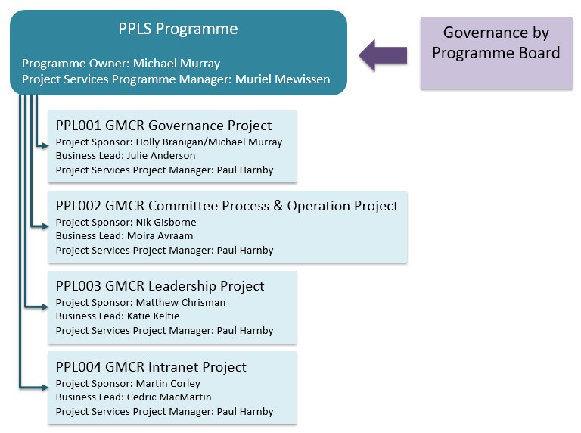

Project RAG STATUS
The project progress is continuously monitored and reported on a monthly basis. The following RAG (RED-AMBER-GREEN) status is used:
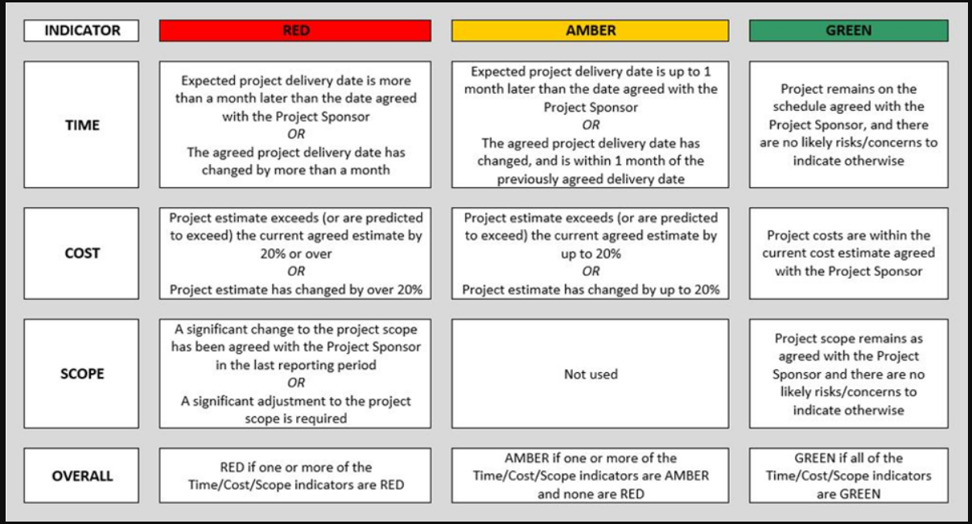

Ongoing, future changes to working group membership and related activities will be agreed by the Sponsor and Business Lead
Logs will assist the operation of the working group and project. An issue log allows for issues that arise to be recorded, dealt with quickly and as they arise. Change log provides a route to agree and approve changes as they arise and helps to avoid scope creep.

