User-uploaded content (internal advertising)

Requests for access to upload content onto large-format timetabling screens should be made in the first instance by emailing learningspacestechnology@ed.ac.uk. This service is only provided to internal university departments for the purpose of displaying content directly related to university business.

Once access to the content management server has been approved, a folder is created with a relevant name and added to the rotating playlist. A user is created on the server and the username and password is provided to the person who made the initial request.

This folder is accessed by going to the following url and logging in with the provided credentials:

http://lst-cms.is.ed.ac.uk

You will be directed to a folder like the one shown below.

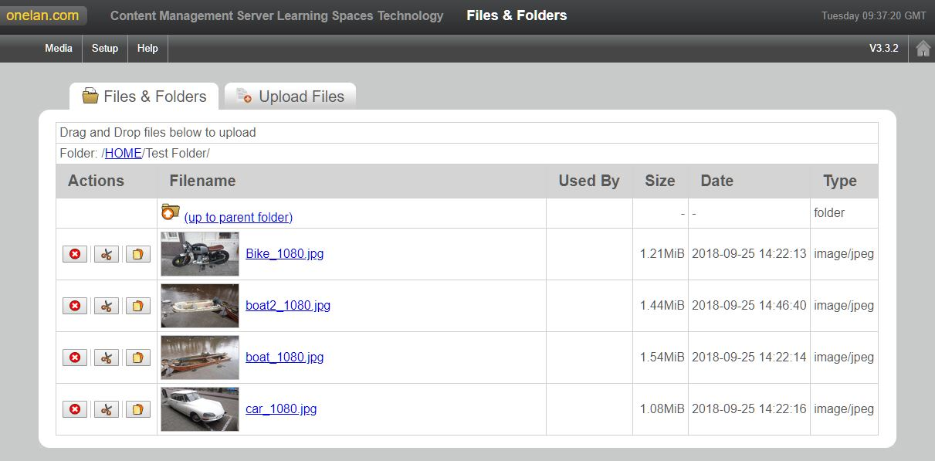

Images can be uploaded either by dragging the files into the folder area in the browser (the box will go green when in the correct location) or by using the “Upload Files” tab. IN this case, click on “choose file”, browse to the desired file then click “upload file” when ready. Uploaded images will appear in the “files and folders” tab. Please do not create folders as content within these may not appear on the screens.

Please note that images should be 16:9 aspect ratio, 1920*1080 resolution and in landscape orientation. Acceptable formats are .jpg and png. All content should follow university guidelines relating to digital signage, available here (LINK)

Content added to this folder will be shown beside timetabling information on larger screens only. Each image is shown for 20 seconds and they appear in random order (though they will be shown together in this folders’ turn in rotation). If more than 3 images are added to the folder then only the first 3 chosen at random will be displayed in each rotation.

To remove files that are no longer required, click on the red “Delete File” button next to the file in question.

Changes are applied to the rotating slideshow within 24 hours of being made, usually automatically in the early hours of the morning. If changes are required urgently, please contact learningspacestechnology@ed.ac.uk or call x504097

Event takeovers of Digital Signage

External (non-university) events should pass all content for display on digital signage via Communications and Marketing for approval. Otherwise the process is as for internal events.

During events and conferences that take over part or all of a building, we offer a service whereby content related to that event can be shown on digital signage for the rooms being used.

Requests for showing event related material should be made by emailing learningspacestechnology@ed.ac.uk. All content must be created in advance and provided to us no less than three weeks prior to the event start.

The following content showing content related to the event is permitted:

Images (1920*1080, landscape, jpg or png).
Web pages controlled by the event organisers (e.g. showing schedules/programmes – recommended in the case of timetabled content as it can allow the event organiser to make their own last-minute changes if necessary)

We do not allow the use of timetabling screens to show any form of social media or other unmoderated content. We also do not permit any content unrelated to the event using the space, nor any external advertising.

Requesting installation of new digital signage

Requests for new digital signage should be made to the Learning Spaces Technology Development team. In the first instance email learningspacestechnology@ed.ac.uk or phone (0131) 6504097.

You will need to specify the content type that the signage will be used for –

- Timetabling
  - Scientia (e.g. for centrally resourced rooms)
  - Office365 (for locally resourced meeting rooms)
- Non-timetabling content
  - See Adams’ section on content creation

You will also need to specify the type of space that the signage will be covering (teaching room, foyer, corridor, etc), the size you would like the screen to be and the available wall space. Payment details will be discussed once details have been confirmed.

Once installation has been completed, if the screen is to showing standard university timetabling then it can be set up to connect to the LST Content management server. Any other usage can be discussed and advice given on how to manage it going forward. Training in use of the Onelan platform is available on request.

Fault reporting / training requests

Any faults or other issues with timetabling screens should be reported in the first instance to the IS helpline, using the online form.

Any requests for Onelan training should be submitted to learningspacestechnology@ed.ac.uk. Training can be provided at any location within the university, preferably using the device that the trainee(s) will be working with subsequently.

Future Plans

Once new timetabling layouts are available for large format screens, the small slideshow of advertising will no longer be available, in order to provide better focus and clarity of content. It is hoped that dedicated advertising screens, also run by LST, will ultimately become available alongside the timetabling screens or in other appropriate areas. These would show the advertising as full-screen images, having far greater impact without being detrimental to the timetabling provision. Content would be added to them by end users in exactly the same way as is done currently.

The rollout of the new timetabling layout will commence as soon as it is available as a robust and supported service. The 22” screens will likely be ready for rollout first, along with a small subset of the 10” and 15” reserva tablets (those connecting to the Scientia timetabling rather than office365, as the reserva software offers no extra features in this case).

The “departure board” layout for larger screens will follow at some point when it becomes available.

